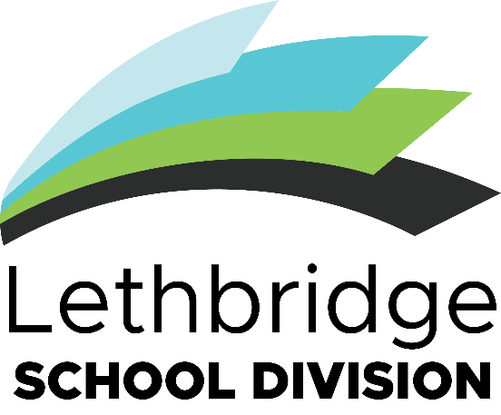Innovation, Creativity and Entrepreneurship (ICE) Scholarship Award Package

The Lethbridge School Division holds the vision that *Learners are innovative thinkers who are successful, confident, respectful, and caring.*

Toward that goal, the division offers the **Innovation, Creativity, and Entrepreneurship (ICE) Scholarship**

to encourage and showcase students who demonstrate these qualities.

While these terms have many interpretations that may come out in projects, here are some examples:

*Innovation* is the ability to generate and implement new and valuable ideas or methods that may apply to real-life situations and creating value for that idea.

*Creativity* is making something new which expresses new ideas or solves challenges in different ways.

*Entrepreneurship* is applying ideas and knowledge to business or commercial opportunities. Projects may focus on any area, but could include focuses such as:

* fine arts, media, and

literature

* science, technology and mathematics
* business entrepreneurship
* trades
* health and wellness
* practical arts such as fashion and foods
* cultural diversity
* environmental studies
* social impact
* horticulture and agriculture
* engineering

Previous award winners can be found here for ideas, inspiration, and celebration: <https://www.lethsd.ab.ca/board/ice-awards-scholarship/past-scholarship-winners>

# AWARD INFORMATION

**Deadline to apply is April 30, 2025.** Please apply on or before this date to be considered. Application period is January 20, 2025 to April 30, 2025.

Minimum 2 x $1000 Awards in Grade 9/10 Category Minimum 2 x $1000 Awards in Grade 11/12 Category

Additional recognition and/or awards are at the discretion of the judging committee.

Scholarships awarded to groups are intended to be split between applicant group members. Scholarships awarded to Clubs are intended to be used by the Club for club-based activities.

# HOW TO APPLY

To apply, you must:

* Ensure you are eligible. The application is eligible if:
  + Applicant is a grade 9,10, 11, or 12 student in Lethbridge School Division
  + The applicant has not received an ICE award for this project before.
* Review the award package including documents (1) *Information Package (2) ICE Scholarship Application Form* and (*3*) *Round 1 Selection Criteria*.
* Identify a project that is:
  + Innovative, creative, and/or entrepreneurial
  + Already Completed, will be completed by the deadline, or will be started after the deadline - April 30, 2025
  + Based on your interests or based on a current class assignment
  + Done by yourself or as a school group or club
* Complete Application Form (15 Questions, including 5 written descriptions of 200 words each)
* Have your Application Form signed by an administrator (i.e. a principal)
* Attach a photo, video, or link as example or demonstration of project if applicable
* Submit your application
  + information [can be found online at lethsd.ab.ca/board/ice-awards-scholarship/](https://www.lethsd.ab.ca/board/ice-awards-scholarship/scholarship-applications) scholarship-applications
  + in person at Lethbridge School Division Education Centre - Aakaipookaiksi (Many Children) at 533 – 15 St. S.
  + email your completed application to [garrett.simmons@lethsd.ab.ca](mailto:garrett.simmons@lethsd.ab.ca)
* If selected as a finalist, present your project in-person before the Awarding Committee in May 2025. Finalists will receive information about what the presentation will include and the Final Round Criteria when notified they have been selected as finalists. Please see timeline attached.

# AWARD TIMELINE

* January 20, 2025 - Application period opens.
* March 27, 2025 – ICE Awards Scholarship Showcase at Winston Churchill High School of previous winners and other examples of innovation, creativity, and entrepreneurship from across the division to promote scholarship and showcase innovation.

# April 30, 2025 – Application Period Closes.

* May 1, 2024 – May 9, 2025 – Selection Committee from Lethbridge School Division Board – Community Engagement Committee selects **4** finalists per category, 8 finalists total.
* May 12, 2025 – Selection Committee will contact all applicants to notify them about the decision and set dates and share criteria for in-person presentations.
* May 14, 2025 – May 30, 2025 – In-person presentations by finalists before the Awarding Committee selected from the Community Engagement Committee, award sponsors and/or community leaders. Date confirmed on May 14 with finalists.
* June 2, 2025 – June 6, 2025 – All finalists contacted and notified of final award panel decisions.
* June 9, 2025 – Award winners publicly announced.
* June 17, 2025 – Award winners presented award cheques at Lethbridge School Division Board of Trustees meeting.
* March 27, 2025 – Award winners from 2024 are invited to showcase their projects at the 2025 ICE Awards Showcase at Winston Churchill High School