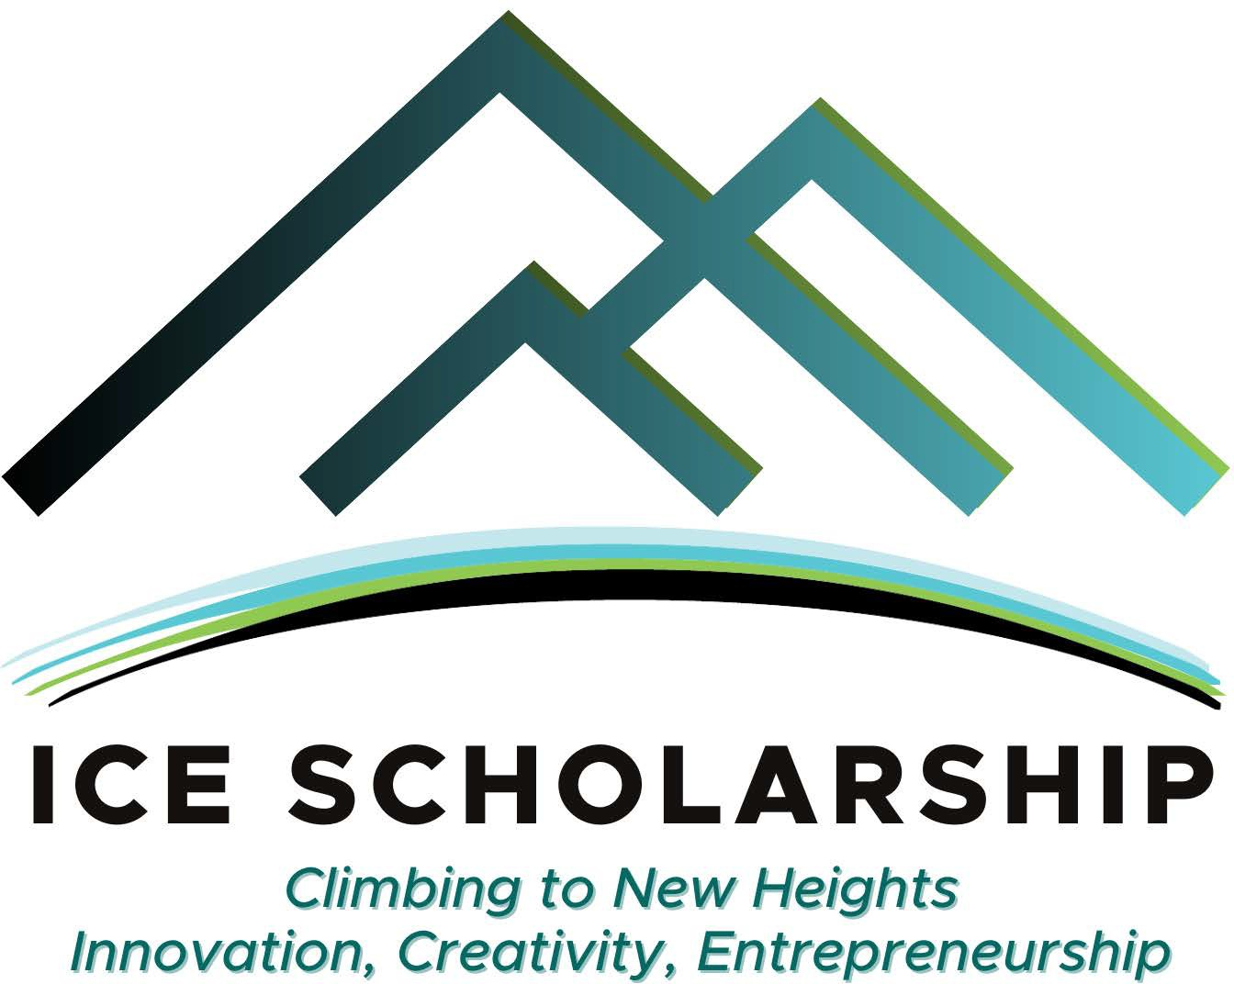
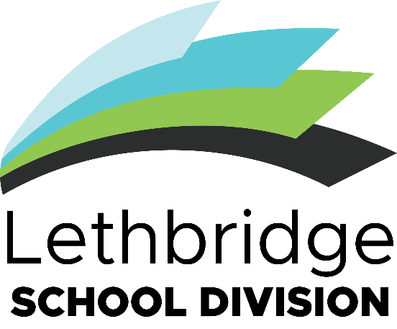
Innovation, Creativity and Entrepreneurship (ICE) Scholarship
Award Package

The Lethbridge School Division holds the vision that Learners are innovative thinkers who are successful, confident, respectful, and caring.

Toward that goal, the division offers the Innovation, Creativity, and Entrepreneurship (ICE) Scholarship to encourage and showcase students who demonstrate these qualities.
While these terms have many interpretations that may come out in projects, here are some examples:
Innovation is the ability to generate and implement new and valuable ideas or methods that may apply to real-life situations and creating value for that idea.

Creativity is making something new which expresses new ideas or solves challenges in different ways.

Entrepreneurship is applying ideas and knowledge to business or commercial opportunities.

Projects may focus on any area, but could include focuses such as:

- fine arts, media, and literature
- science, technology and mathematics
- business entrepreneurship
- trades
- health and wellness
- practical arts such as fashion and foods
- cultural diversity

- environmental studies
- social impact
- horticulture and agriculture
- engineering

Previous award winners can be found here for ideas, inspiration, and celebration:
https://www.lethsd.ab.ca/board/ice-awards-scholarship/past-scholarship-winners
AWARD INFORMATION
Deadline to apply is May 6, 2024. Please apply on or before this date to be considered.
Application period is January 22, 2024 to May 6, 2024.
Minimum 2 x $1000 Awards in Grade 9/10 Category
Minimum 2 x $1000 Awards in Grade 11/12 Category
Additional recognition and/or awards are at the discretion of the judging committee.
Scholarships awarded to groups are intended to be split between applicant group members. Scholarships awarded to Clubs are intended to be used by the Club for club-based activities.
HOW TO APPLY
To apply, you must:
- Ensure you are eligible. The application is eligible if:
  - Applicant is a grade 9,10, 11, or 12 student in Lethbridge School Division
  - The applicant has not received an ICE award for this project before.
- Review the award package including documents (1) Information Package (2) ICE Scholarship Application Form and (3) Round 1 Selection Criteria.
- Identify a project that is:
  - Innovative, creative, and/or entrepreneurial
  - Already Completed, will be completed by the deadline, or will be started after the deadline- May 6, 2024
  - Based on your interests or based on a current class assignment
  - Done by yourself or as a school group or club
- Complete Application Form (15 Questions, including 5 written descriptions of 200 words each)
- Have your Application Form signed by an administrator (i.e. a principal)
- Attach a photo, video, or link as example or demonstration of project if applicable
- Submit your application
  - online at lethsd.ab.ca/board/ice-awards-scholarship/scholarship-applications
  - in person at Lethbridge School Division Education Centre - Aakaipookaiksi (Many Children) at 533 – 15 St S.
  - email your completed application to garrett.simmons@lethsd.ab.ca
- If selected as a finalist, present your project in-person before the Awarding Committee in May 2024. Finalists will receive information about what the presentation will include and the Final Round Criteria when notified they have been selected as finalists. Please see timeline attached.

AWARD TIMELINE
- January 22, 2024 - Application period opens.
- March 20, 2024 – ICE Awards Scholarship Showcase at Chinook High School of previous winners and other examples of innovation, creativity, and entrepreneurship from across the division to promote scholarship and showcase innovation.
- May 6, 2024 – Application Period Closes.
- May 7, 2024 – May 12, 2014 – Selection Committee from Lethbridge School Division Board – Community Engagement Committee selects 4 finalists per category, 8 finalists total.
- May 13, 2024 – Selection Committee will contact all applicants to notify them about the decision and set dates and share criteria for in-person presentations.
- May 14, 2024 – May 31, 2024 – In-person presentations by finalists before the Awarding Committee selected from the Community Engagement Committee, award sponsors and/or community leaders. Date confirmed on May 13 with finalists.
- June 3, 2024 – June 7, 2024 – All finalists contacted and notified of final award panel decisions.
- June 10, 2024 – Award Winners publicly announced.
- June 25, 2024 – Award Winners presented award cheques at Lethbridge School Division Board of Trustees meeting.
- Spring 2025 – Award Winners invited to show case their projects at the 2025 ICE Awards Showcase

