LETHBRIDGE SCHOOL DIVISION
Elementary Wrestling Program
Tuesday Evenings 6:30 – 7:30
from
January 7 to March 17
(10 Sessions, February 18th excluded)
General Stewart School
215 Corvette Crescent S
Cost: $50 includes a T-shirt
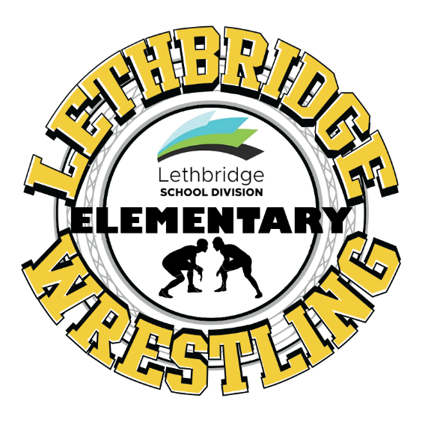
Registration and Information forms are available at all Lethbridge School Division Elementary Schools or by emailing chris.harris@lethsd.ab.ca
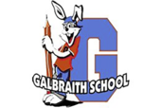

Hello Lethbridge School Division Families,
Our school district is very excited to offer an Elementary School Wrestling program. The program will run Tuesday evenings from 6:30 – 7:30 at General Stewart Elementary School. This program is open to K-5 students from all schools in Lethbridge School Division. The philosophy of this program is to introduce student-athletes to the sport of wrestling and to develop their skills and fitness through games and basic athletic movements. Introduction of basic wrestling fundamentals will also be taught through movement and games. While there may be opportunities for some older students to participate in competitions, this will not be the primary focus. Our focus will be on building a love and appreciation for the sport of wrestling in a fun, positive environment while learning sportsmanship, building confidence and self-esteem, promoting physical and emotional development, and learning how to work and cooperate with others. This is a school district program but the Lethbridge Amateur Wrestling Association will be supporting the program by providing mats and other resources.
If you are interested in having your child participate in the program, please complete the bottom portion of this form and return it to the office at your child’s school. They will be sent via inter-school mail to general Stewart for registration. Alternatively, you can also email the form directly to chris.harris@lethsd.ab.ca
There is an Acknowledgement of Risk form that must be completed prior to participation. The cost of the program is $50 that covers participation in all of the practices as well as a Lethbridge School Division Elementary Wrestling Program T-shirt. It will run from Tuesday evenings from January 7 – March 17, except for February 18th which falls during the Family Day break. As mentioned previously, there may be opportunities for some students to compete in competitions. If your family chooses to participate in a competition, there will be an additional cost for insurance and registration. More information regarding competition will be provided upon request at a date closer to possible competition dates.
Chris Harris
Principal
General Stewart elementary School
------------------------------------------------------------------------------------------------------------------------------------------
Name of Athlete: ___________________________________
School: _______________________________________ Grade: ___________________________
Date of Birth: ______________________________________________
Parent/Guardian: _____________________________________________________ Ph: _____________
Emergency Contact: ___________________________________________________ Ph: _____________

