**How to Search for and Book Resources**

**from the**

**Curriculum Resource Centre**

1. **Go to:**  <http://destiny.lethsd.ab.ca> and select your home school.
2. Select the “Catalog” tab.
3. Select the “Login” button to log into your home school’s catalogue program.
4. **Use your own Division login and password.** [If you cannot log in, you may not yet be assigned to your new site. Contact the Curriculum Resource Centre.]
5. This is the screen you will now see.
6. To search the Curriculum Resource Centre you must “check the box” beside Curriculum Resource Centre.
7. You must “uncheck” your school if you do not want to search your school as well.
8. Enter your search.

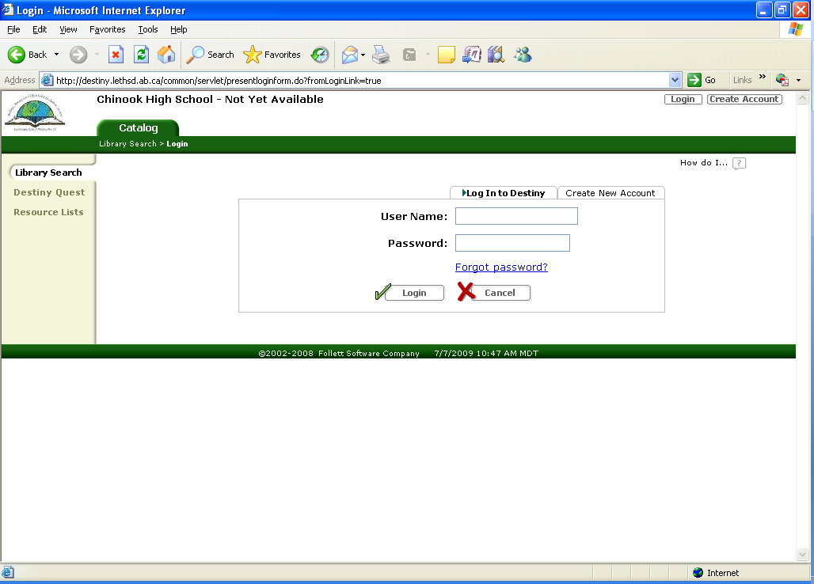

Your school Name here

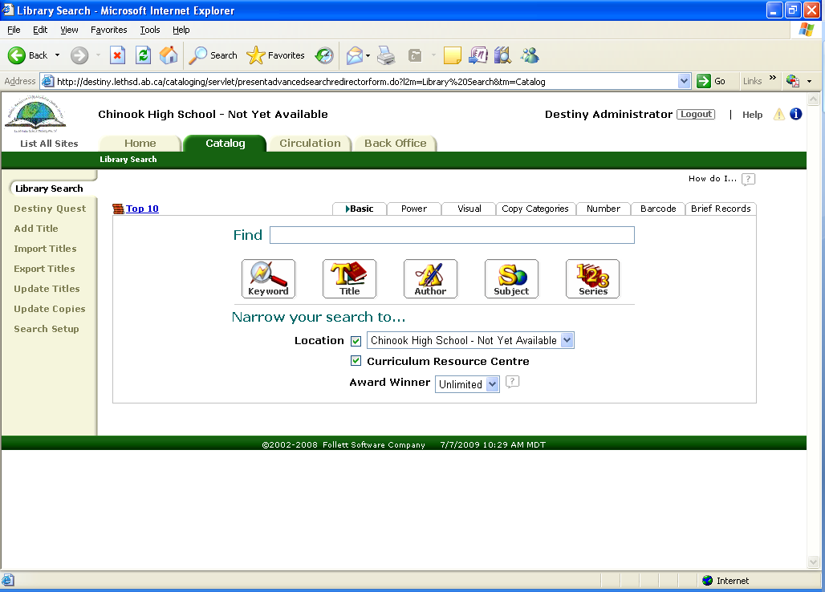\

Your school Name here

Your school name here

1. Example of a search: type in “guided reading” then select the “Keyword” button.
2. Here is what your search will give you. This search for guided reading found 35 items. The first few are shown here.
3. As an example, imagine you chose the second item as the one you want to book online.
4. Click on the title to get the information on this item.

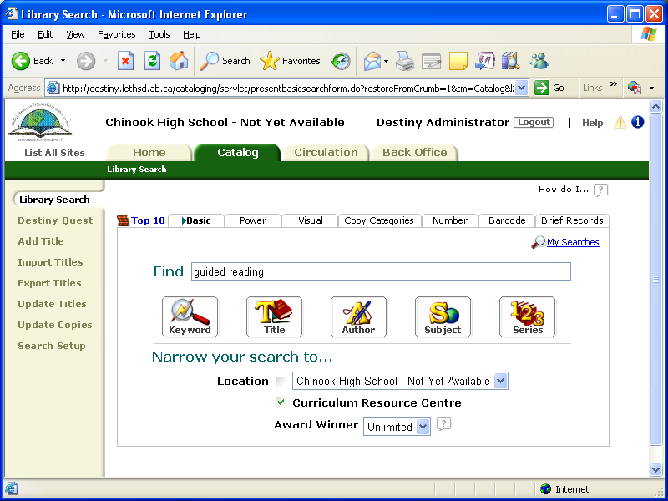

Your school Name here

Your school name here

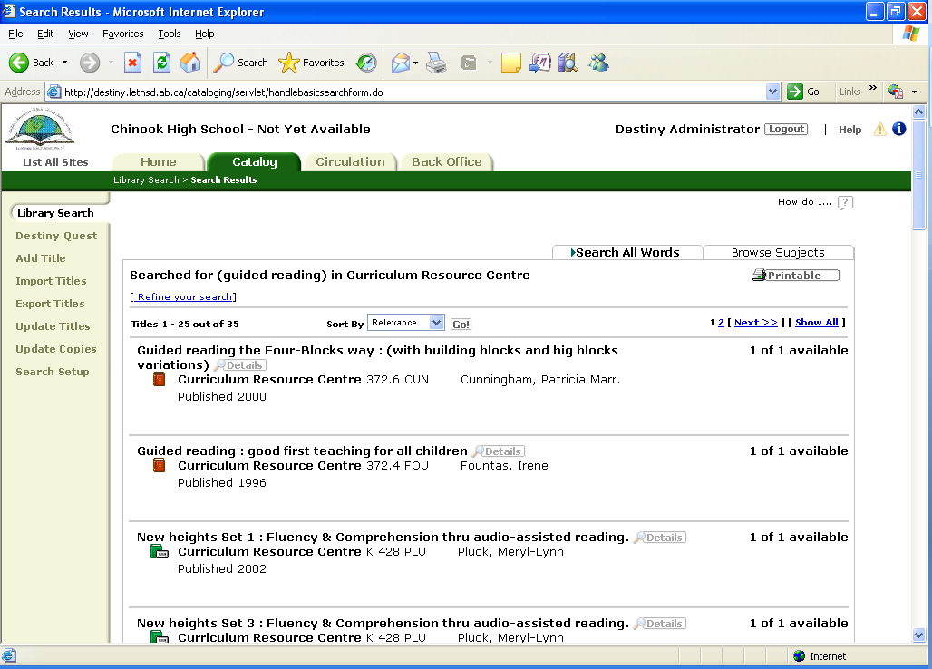

Your school Name here

1. This is the screen you will see.
2. Select **“Book It”** if this is an item you want to order.
3. This is the screen that will appear.
4. You can now book or reserve this item on-line.
5. To enter the date you wish to receive the item, select that date on the calendar.
6. The beginning and end time will appear in the boxes. You will see the maximum loan period info below the dates. You can book for a shorter period but not for a longer period.
7. **NOTE:** For novel kits only you can book a second loan time to immediately following your first booking.
8. Select **“SAVE”.** A request will be sent.

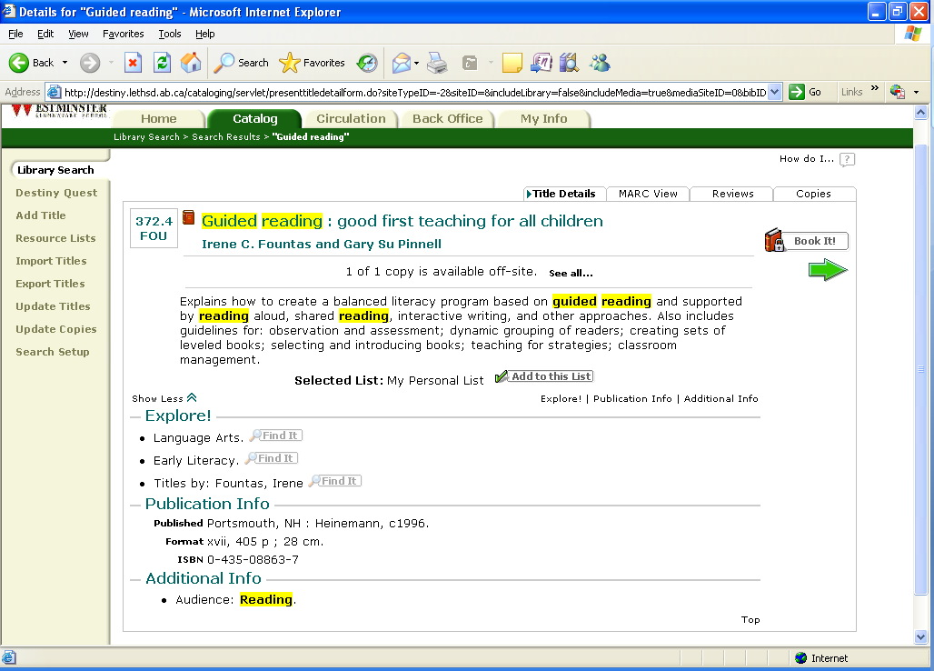

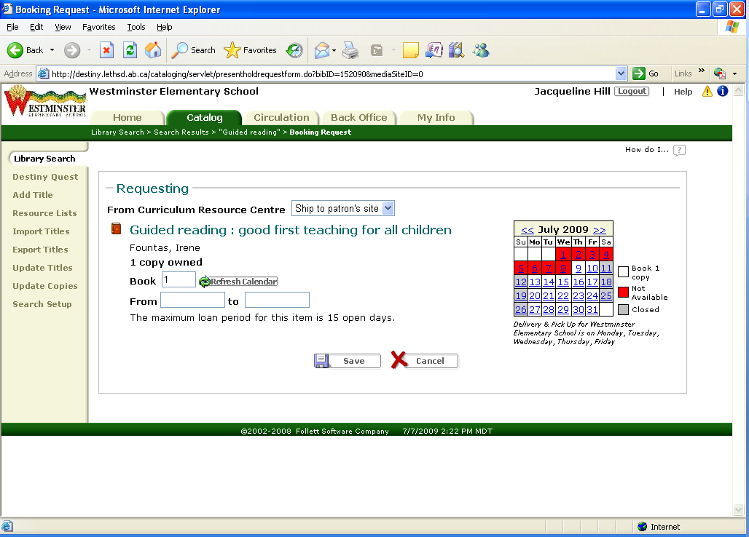

Your school Name here your name appears here

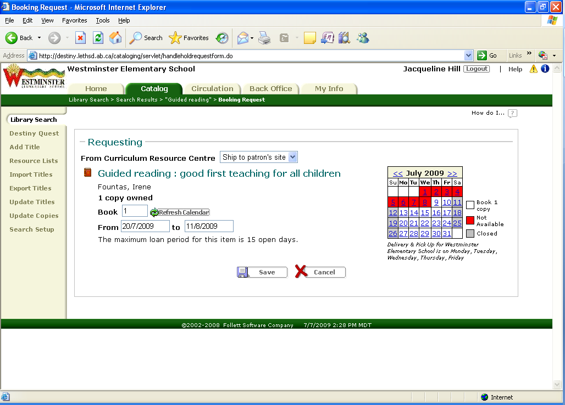

Your school Name here your name appears here

1. Select “My Info” to see the status of items you have, either currently checked out, pending, or overdue.
2. This will show all your items both from your school and from the Curriculum Resource Centre. Note the RED [CRC] which indicates the item is from the Curriculum Resource Centre.
3. If you change your mind about the dates you booked the item for, you can EDIT the entry by selecting the “edit” button.
4. If you booked an item by mistake or change your mind, you can DELETE it by selecting the “garbage can” beside the item.

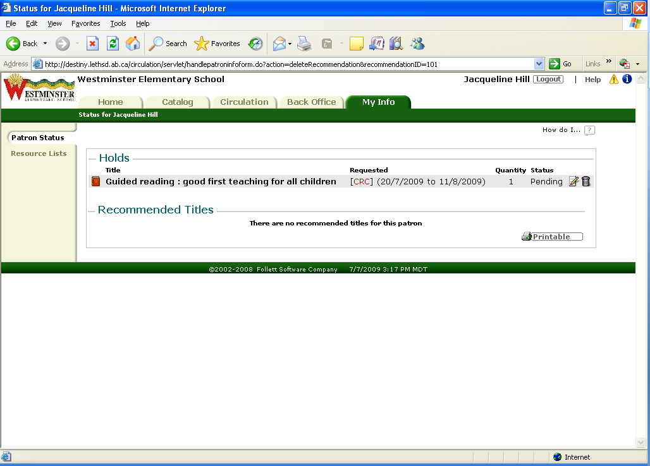

Your school Name here your name appears here

1. If you have any questions please contact Kathy at the Curriculum Resource Centre either by e-mail: [kathy.knelsen@lethsd.ab.ca](mailto:kathy.knelsen@lethsd.ab.ca) or by phone at 403-380-5319.