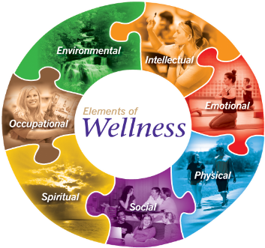
Wellness Committee Meeting # 2
This Photo by Unknown Author is licensed under CC BY-NC-ND

Thursday, January 30, 2020

Ed Center, Computer Lab

1:15 to 3:30 pm

AGENDA

- Introductions

- Member updates

- Nutrition (T. Leggat- Inclusive Ed Coord.)
- Counselling (K. Mundell- Counselling Coord.)
- Human Resources (R. Jesse- HR)
- Smudge Protocol (M. Asquith)
- Chris Windle
- Lyndsey Spring

- AHSCWF- $20,800- middle schools outdoor initiatives- struggles

- Health Champ planning- shifting these meetings to networking and learning opportunities, Alison and Kurt are at EverActive this week- they will be bringing back learning- a need to focus on FNMI wellness – feedback around what PL would be worthwhile, next agenda ?

- Indoor recesses – Lyndsey providing ideas/sharing

- Parent wellness- Diversity and Inclusion Table discussion- how can we support parent wellness as a Division- healthy parents=healthy students, do we know what our parents think/believe about wellness ?

- Physical activity initiatives- ideas from the Committee

- Wellness Website- ideas from the Committee

- Struggles impacting wellness- SRO decline, Making Connections, Fridays for Kindergarten teachers, FNMI staffing decline

