Lethbridge School District
Health Champions Workshop
February 26, 2020
1:15-3:15pm
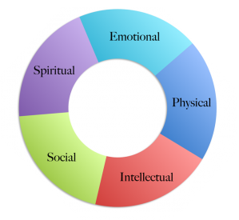

AGENDA

1.  1:15-1:30  (15min) | Introductions  One Star – wellness success at your school  One Wish – PD you would like to see for May’s full-day meeting | Morag  Morag  Lyndsey
2.  1:30-2:20  (50min) | E-Cigarettes  Ice Cream Truck Video  Vaping presentation (30min)  Lloydminster student video  E-Cig student led projects  Q&A | Katie Clampitt
3.  2:20-2:50  (20min) | Shaping the Future  Report & Activity | Ali & Kurt
4.  2:50-3:10  (20min) | Cold Weather Recess | Lyndsey
5.  3:10-3:15  (5min) | Outdoor Learning Ideas  Wrap-up | Morag

