Healthy School Champion Meeting #1- October 9th
“Let’s Network”

AGENDA
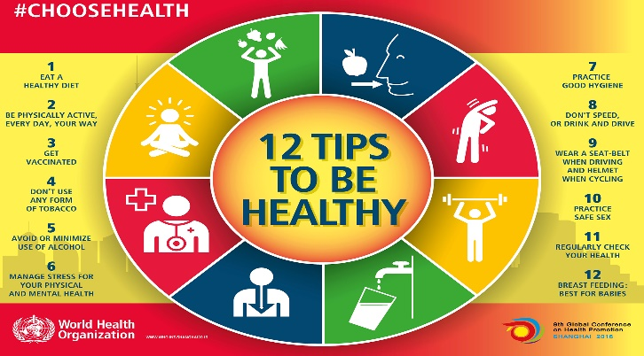

- Activity- Networking sharing activity (Steph)

- Presentation on other promising practices- provincially (Steph)

- Professional Learning inventory-what do we want to learn more about or what are our schools wanting ?

- Roles and Responsibilities of the Healthy Schools Champion, Wellness Policy and Wellness Procedure (in a package)

- Staff Wellness Throw-down Schedule

- If 50% of staff participate the Health Champ will just enter “Y” or “N” into the shared document monthly. Then the schools that have 50% participation in the Throw Down will qualify to enter a draw for $200 toward a Staff Wellness activity.

- There will be 4 “independent challenges” anyone on staff that accomplishes the challenge will report to their Healthy Schools Champ and they will be recorded into the shared document as well. The “independent challenges” will be held in November, January, March and May. Anyone who completes the 4 challenges will go into a draw for a Smart Watch at the end of the year
-October challenge- Challenge all staff to spend at least 1 lesson outside (or be outside during school time for at least 30 minutes)
-November challenge- Challenge 10,000 steps every day of the month
-December challenge- Choice in either sending a gesture (participant decides what) of thanks or starting a gratitude journal
-January challenge- Committing to a routine for physical activity that is an enhancement from what you currently do
-February challenge-Have a water bottle with you wherever you go
-March challenge- Nutrition- two shared and prepared meals a week
-April challenge- about connection-being curious/ asking questions in a positive way to someone
6. Healthy Communication and work-life boundaries activity- Morag

- Human Resources- EFAP/ASEBP info

- Nutrition Programming- Terra Leggat

