Lethbridge School District No. 51
Wellness Work Plan
2017-2020
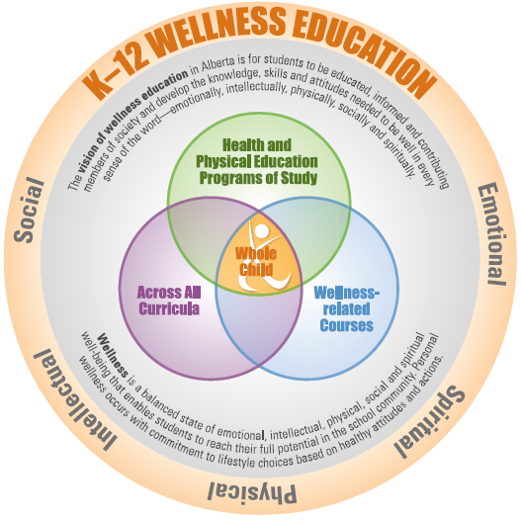
Wellness Work Plan
Overarching umbrella of Universal Design for Learning- Building an inclusive, positive school culture that embraces diversity and facilitates access for all learners. There will be :

- Healthy Schools Forum- determined next three years direction- Mental Health Prevention work, examine structures within our school setting that impact Wellness- 2020 will be next Health Forum
- Healthy Schools Champions- 3 workshops/meetings
- Wellness Committee- 3 meetings a year plus subcommittee work (Policy work for 2018/19)
- Policy review- honor the Healthy Nutritional Choices Policy (504.11) and support the new Wellness Policy and Procedures drafted in May 2019- communication roll out to discuss with Garrett
- Health Curriculum work- meet 3X with Health Teachers and C.A.L.M. through the year to initiate a scope and sequence (including Digital Citizenship work)- partner with Curriculum and Counselling for 19/20 support new Counselling Coordinator
- Tobacco and Cannabis- continue to work with AHS in substance misuse education and communicate out to parents (drug and alcohol presentations)
- Healthy Food Choices- Continue to support schools on offerings unsweetened beverages (including artificial sweeteners), cafeteria selling smaller portions, vending machines at schools adhering to Alberta Food Guide
- Nutrition Programs – Alberta Education Nutrition Program ceasing (2019) and exploring other agencies/community that can support the nutritional needs of our students, seeking financial support for the District Fruit and Vegetable program that started in the 2018/19 school year
- Sleep- was focus for 2017/18 but continue to support how to encourage students, staff and parents to embrace healthier sleep habits (tech use)
- Staff Wellness Throw down – focus for the 2018/19 school year supporting wellness district wide, continue and fine tune for 2019/20 school year
- Self-regulation and staff wellness- focus for the 2017/18,2018/19 and 2019/20 school year start to look at high school transition to post sec and wellness support
- University of Lethbridge- Nurse practicums at our high schools
- Physical activity- explore next steps into 2019/20 (Steph presented to Health Champs in May 2019)

Year 2 (2017/18) | Year 3 (2018/19) | Year 1 (of new cycle 2019-20)
Sleep- Parent night to increase information about the importance of this, newsletter share, Alberta Health Services initiative at STAPLES and at Ready, Set, Go, connection to self-regulation and Laura Paiement Wellness Series. Counselling will host parent night that will involve the issue of sleep. | Plan at end of 2018 for upcoming year. | Continue to support sleep education in 6-12 classes – health forum concept is growing (SJF)  -perhaps another parent education
Continue vision from 2016/17 | Continue vision from 2016/17 | Health Forum 2019 (November)
Policy Review and Change- worked with Healthy Schools Committee on Policy work for the year. Result: change in daily food offerings first in our District.  Vending machines and Munchies eliminate artificially sweetened beverages and candy sales. | Policy Review and Change- Wellness policy to be drafted that is all encompassing- will integrate all elements of Wellness- spiritual, intellectual, social, emotional and physical.  Update Nutrition Policy. | *New* Wellness Policy and Procedure  -share with administrators, DSC, Wellness Teams, HR
Health Curriculum Work- to finalize a Health Curriculum document and have shared with all Health/CALM teachers (alignment with work experience, careers, sexuality, digital citizenship, safety, relationships, utilization and incorporation of MyBlueprint | Healthy Curriculum Work- May need another year of work. | New curriculum  -pending- K-4 new government- continue to support physical education and health
Tobacco and Cannabis- continue work around preparation for cannabis legislation (“substance misuse” vocabulary) | Tobacco and Cannabis- staff procedures revised | Substance Misuse Policy –revised, continue to solicit support from AHS (Substance Education)
Healthy Food Choices- Morag to work with Administrators on vending machines only offering healthy food/drink options.  Have established an agreement with Munchies that they will not serve beverages with artificial sweetener or candy in High School Cafeteria. | Healthy Food Choices-  Revise Nutrition Policy to reflect new shift continue to promote communication around “Wellness” | Healthy Food Choices- beef up Healthy Nutritional Choices Policy now that Wellness Policy is complete, continue to support high school cafeteria offerings, remind middle and high school about vending machines
Nutrition Programs- support and guide programs to run as nutrition programs versus food programs following Alberta Nutrition Guidelines for Children and Youth.  Support healthy food celebrations and ideas- meet once or twice a year with Healthy School Champions regarding PL on nutrition.  **11 schools to participate for upcoming year, District Fruit and Vegetable program initiated | Nutrition Programs- support schools in following new policy and guidelines/protocols. Create more of a consistent approach with food delivery and education. | Nutrition Programs- Alberta Education support discontinued, schools have to procure their schools support (i.e. Breakfast Clubs of Canada, President’s Choice, Interfaith, etc.) attempt to continue the District Fruit and Vegetable program
 |  | Physical Activity- survey schools in 2019/20
Wellness Grant- successful schools: Mike Mountain Horse, Wilson, Senator Buchanan, Ecole Agnes Davidson, Fleetwood Bawden, Dr. Probe, Coalbanks, Galbraith and Lakeview. Majority of the grants are tied to self-regulation and sensory equipment.  Laura Paiement (self-reg. guru) to host 2 evenings and consult to schools through the year. Laura also presented to parents and Support staff  Release second application in May 2018. | Wellness Grant- continue self-regulation and staff wellness identified as priorities. 16 applications for Wellness Grants. 14 schools will be supported with self-regulation/staff wellness this year. | Wellness Grant- continue to support Self-Regulation and move into more physical activity initiatives- high schools ?
Healthy Schools Committee and Health Champions- meet 3-4 X with the HS Committee, work on defining Health Champs roles with group. | Healthy Schools Committee and Health Champions- meet 3-4 X with HS Committee, share Health Champ roles and responsibilities. | Healthy Schools Committee and Health Champions- meet 3X with Wellness Committee, share Health Champ roles and responsibilities meet with Health Champs 3 X.
Staff Wellness- continued work around WHIP and EAP promotion | Staff Wellness- Wellness Grants can support this, “Wellness Throwdown”, WHIP and EAP | Staff Wellness “Throw Down” -continue (year 2)  Monthly themes-  September- “Get outside”  October- “Steps”  November- “Digital awareness”  December- “Gratitude”  January- “Get Moving” February-“Hydrate”  March- Dieticians of Canada Nutrition month- topic to be determined  April-“Celebrate Diversity”  May- AHS and CMHA partnership theme to be determined

