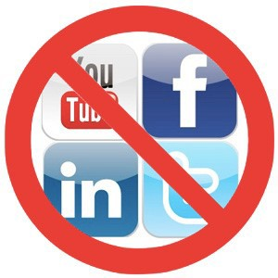
Social Media Fast

Staff Wellness December Throw Down Challenge

We challenge you and your staff members to eschew social media and
encourage more face to face contact with your friends, family and peers in this holiday season. Social media for this challenge includes Facebook, Twitter and Instagram.
For the week of December 10th to the 15th staff are encouraged to put a message on their social media accounts indicating they are away for this 5 day period.
On December 17th each staff is to report to their Health Champion if they have accomplished this goal. If 50% of your staff complete the challenge the Health Champion will report this accomplishment to Deb Bosch.

Some key benefits of Face to Face communication…
- There is no greater way to gauge what an individual is thinking than to speak to them in person. Spoken words account for less than 10% of the communication between humans. The rest consists of body language, voice inflection, facial cues etc. Social media does not allow one to communicate
with someone on a level that will allow one to “read” the subtleties in their communication that are
not made up of actual words.

- It also allows you to get a clear picture of how well your message has been understood.

- One of the biggest advantages of face to face communication is that it can create a bond of trust between people in a way that electronic communication simply cannot.

- Face to face communication allows for discussion as there is immediate feedback from the listener.

- Speaking to someone in person can make it much easier to motivate them.

